Windows Features

# Task 1: Device Manager

|  |  |
| --- | --- |
| **Hardware components** | **Model & Specifications** |
| **CPU** | Intel® Core™ i5-4590 CPU @3.30GHz x4 |
| **Graphic Card** | Intel® HD Graphics 4600  AMD Radeon™ HD 8350 |
| **Optical Drive** | WDC WD5000AAKX-60U6AA0 |
| **Monitor** | Generic PnP Monitor (Acer) |
| **Network Card** | Intel® Ethernet Connection Adapter  TAP-Win32 Adapter V9 |

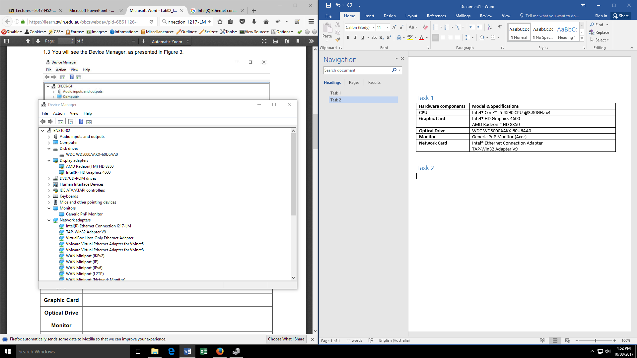

# Task 3: Turn off Internet Explorer

See file T2.3.zip

# Task 4: God Mode

We created a folder and called it: GodMode.{ED7BA470-8E54-465E-825C-99712043E01C}

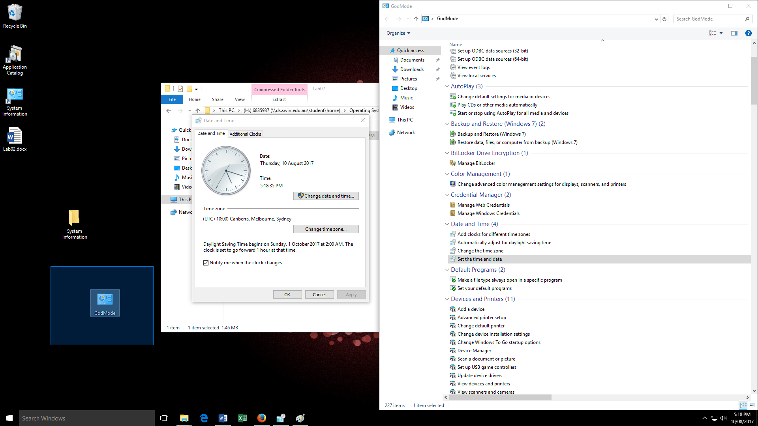

Here is can be seen using one of the GodMode option to adjust the time and date.

# Task 5: Reliability Monitor

Here you can see a screen shot of the Reliability Monitor showing when the critical events happened.

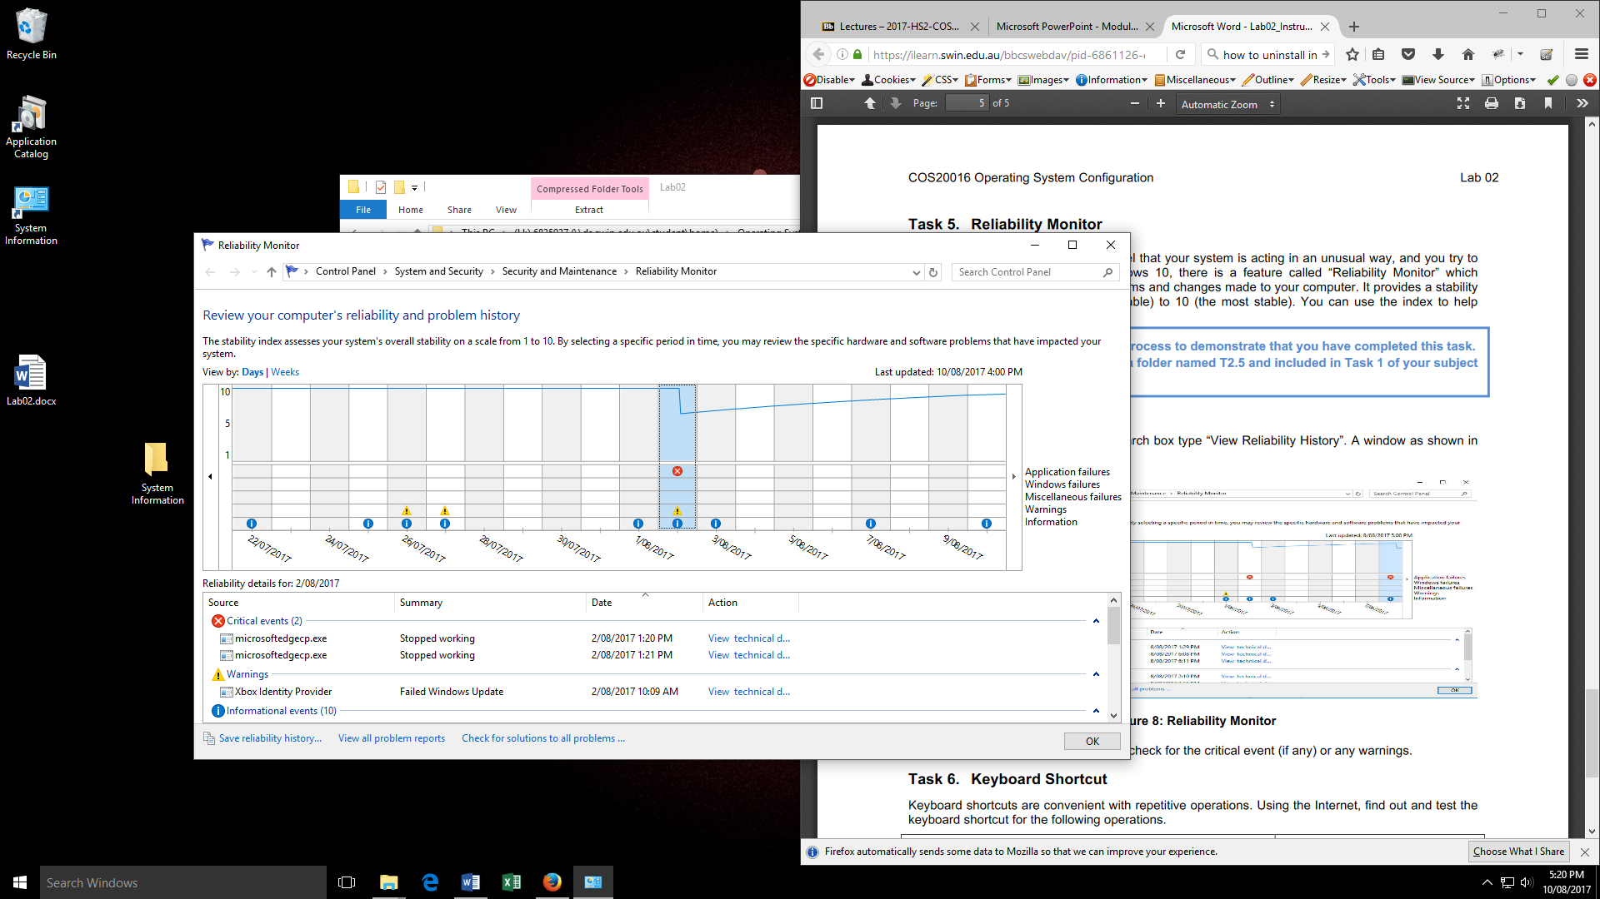

# Task 6: Keyboard Shortcuts

|  |  |
| --- | --- |
| **Operations** | **Keyboard Shortcut** |
| Open File Explore | Windows logo key + E |
| Delete files and folders permanently without using the Recycle Bin | Shift + Delete |
| Minimise all windows | Windows logo key + D |
| Switch through opened folders, files and running applications | Alt + Tab |
| Close the current (focused) window or application | Alt + F4 |
| Lock the computer without having to log out | Windows logo key + L |
| Create a new folder | Ctrl + Shift + N |